36. Recognise a Watch from the Given Image Using General Object Recognition with OpenCV
Aim:
To recognize a watch from a given image using general object recognition techniques in OpenCV.
Algorithm:
- Import OpenCV and load the input image.
- Read the image using cv2.imread().
- Resize the image if required.
- Convert the image into a suitable format.
- Use a pre-trained object detection model such as MobileNet-SSD.
- Detect objects present in the image.
- Compare the detected class with the target object “watch”.
- Draw a bounding box and label around the detected object.
- Display the output image.
Python Program:
from ultralytics import YOLO
import cv2
# Load YOLO model
model = YOLO("yolo11n.pt"
# Read image
image = cv2.imread("watch.jpg")
# Check image
if image is None:
print("Image not found!")
exit()
# Detect objects
results = model(image)
# Display result
annotated_image = results[0].plot()
cv2.imshow("Watch Object Recognition", annotated_image)
cv2.waitKey(0)
cv2.destroyAllWindows()
OUTPUT: 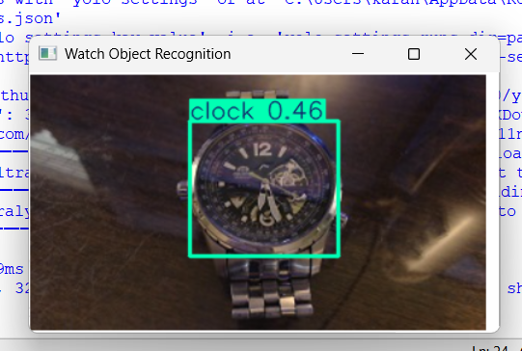
Result:
The given image is processed using OpenCV and a pre-trained object-recognition model, and the detected object is displayed with its label and confidence score.

